**Computer Network Fundamentals**

**Research the following Networking Areas**

1. **Define the term Local Area Network (LAN).**

A LAN is a small network of machines connected together, such as in a private home or business. The router connects this LAN to outside networks.

1. **What are the differences between Baseband and Broadband networks?**

Baseband uses digital signalling over a single cable to send and receive data, where it is not possible to send and receive simultaneously.

Broadband uses analogue signalling over waves using various frequencies. Data can be send and received simultaneously.

1. **Describe with a diagram four types of network topology.**

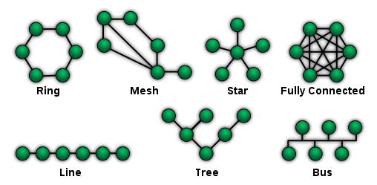

By NetworkTopologies.png: Maksimderivative work: Malyszkz (talk) - NetworkTopologies.png, Public Domain, <https://commons.wikimedia.org/w/index.php?curid=15006915>

1. **Describe why a repeater is used within a network.**

To extend the coverage of WIFI signal within a LAN.  
A repeater effectively contains two parts, one picks up the signal, the other to then re-broadcasts it at full strength.

1. **A router is an integral part of a computer network. What is its function?**

Connects a subnet with other subnets – ie. The internet.  
It sends and receives data from computers on one network, directing it to its destination on another.

1. **A Wide Area Network provides additional functionality over a Local Area Network. Discuss this additional functionality (be brief, just create a list).**

WANs span a much larger area, and can cover most of the world in the case of the internet.  
Harder to maintain  
Low bandwidth, slower  
No single owner, made up of many interconnected devices such as routers, which can be preparatory

1. **Many towns and cities have Metropolitan Area Networks. Describe the main functions of this style of network.**

Larger than a LAN, but smaller than a WAN  
Used to group together devices into a single network across multiple buildings in an area.  
Often owned by a single group.  
Could be used in a large shopping centre to provide internet access throughout the buildings.

1. **Describe two types of NIC (eg wiring…).**

Two popular types of network interface card connect a device to a network either using a Ethernet cable, or wirelessly.

1. **What are the main differences and advantages of Full Duplex and Half Duplex data transfers?**

Full duplex lets you send and receive data to and from a device simultaneously.  
Half duplex on the other hand can only send then receive when one operation is complete, or vice versa.

OPTIONAL:

1. **Data collision can be an issue with certain network topologies. A Token Ring network can eradicate this issue. Describe, with the aid of a diagram the function of this style of network.**